De Maistre, LeRoy Leveson Laurent Joseph (de Maistre, Roy, 1894-1968)

Roy de Maistre was born in New South Wales and is recognised as an initiator of modern art practises in Australia. Aware of the new European painting schools of Post-impressionism and abstraction only through reading, de Maistre worked to devise a method of allying colour tones with musical notes and used the findings to produce works stylised in form and colour. This interest in colour, music, and decorative geometric form would characterise his future work. De Maistre also worked in design, first in the field of colour therapy for shell-shocked soldiers and later producing a colour wheel – patented as The De Mestre Colour Harmonising Chart – which gave directions for the matching of colours and tones and became very popular with interior decorators. In the 1930s, after moving to England, de Maistre joined the avant-garde group of painters centred round Herbert Read and the Mayor Gallery, London. He later became known as a painter of mainly religious works depicted in his highly coloured decorative cubist style. Besides being known for his own work, de Maistre is recognised for his formative influence on the British painter Francis Bacon and the Australian writer Patrick White.

De Maistre was a student of art and music in Sydney when he gained notoriety for an exhibition held in 1919 with fellow artist Roland Wakelin. The small stylised paintings, in which the artists allied colour tones with musical notes, paved the way for Australia’s first abstract painting, Rhythmic Composition in Yellow Green Minor, produced by the artist later the same year.
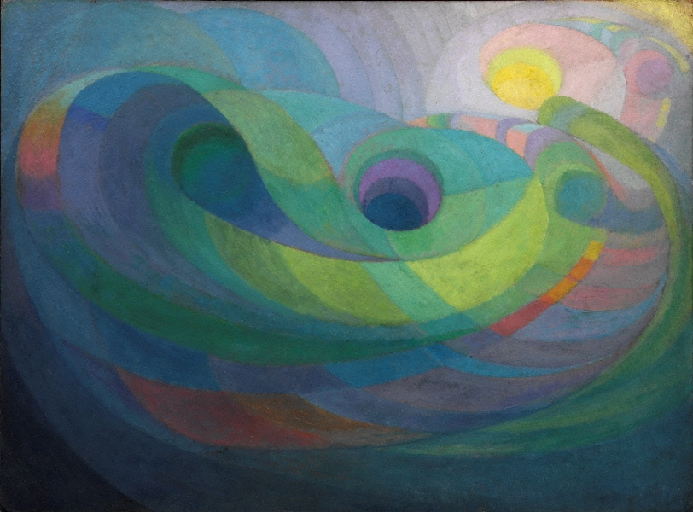
Roy de Maistre, Rhythmic Composition in Yellow Green Minor, 1919, oil on paperboard, 85.3 x 115.3 cm, collection: Art Gallery of NSW, Accession no: OA17.1960 (http://www.artgallery.nsw.gov.au/collection/works/OA17.1960/)

In 1923 de Maistre won the Society of Artists travelling scholarship, enabling him to spend eighteen months painting in Europe and to exhibit in the 1924 Société Nationale des Beaux Arts exhibition in Paris. Returning to Australia in 1925, he found the art community largely unsympathetic to abstract art, and modified his painting style to one of a stylised, rather than abstracted, modernism. For the next four years de Maistre continued painting and working on decorative projects, such as the painting of the Children’s Chapel in St James Church, Sydney. In 1930, he left Australia never to return.

De Maistre settled in London, where he was quickly absorbed into the London art world, exhibiting with Francis Bacon in 1930. Bacon exhibited furniture and rugs, and de Maistre paintings. Between 1930 and 1940, de Maistre was involved with theLondon’s avant-garde artists centred on the Mayor Gallery, and had work featured in the first edition of Herbert Read’s Art Now (1933). He had regular one-artist exhibitions in several London galleries, as well as in Birmingham, Manchester, and Leeds. He also exhibited frequently in group exhibitions, and was featured in articles and books, such as John Rothenstein’s Modern English Painters. De Maistre dabbled in Surrealism, but mainly worked in a style with Post-impressionist and Cubist features. In 1934 he returned to his colour/music work and produced several large abstract works based on musical passages, as well as plans for a filmed colour/music ballet. He formed work and social connections with many well-known figures including Bacon, prominent art critic Rothenstein, politician Rab Butler, dance critic Nigel Gosling, and Patrick White.

After 1940 de Maistre was mainly known as a painter of religious works, in which he painted devotional subjects with stylised colour and form, often including musical references. He was commissioned to paint The Stations of the Cross in Westminster Cathedral, London and his work was purchased by several English public galleries, including the Tate Gallery London, which has five of his paintings. De Maistre died in London in 1968.

References and further reading

Edwards, D. et al (ed.) (2013) Sydney Moderns: art for a new world, Sydney: Art Gallery of New South Wales.

Hutchinson, N. (2014) http://www.colourmusic.info/maistre.htm (This is a web site devoted to colour music; the first section concerns the work of de Maistre.)

Johnson, H. (1988) Roy de Maistre. The Australian Years 1894-1930, Sydney: Craftsman House.

Johnson, H. (1995) Roy de Maistre. The English Years 1930-1968, Sydney: Craftsman House.

Stephen, A. et al (eds) (2008) Modern Times. The Untold Story of Modernism in Australia, Sydney: Powerhouse Publishing.

___________________________________________

Copyright holders on de Maistre’s work (both need to be consulted).

Caroline de Mestre Walker,

caroline.dem_walker@yahoo.co.uk

Belinda Price,

Jamesbelinda.price@talktalk.net

